**Application Name:** RouteFinder

**Group Members:**

1. Jack Pfeiffer (pfeiffej@uci.edu)
2. Jonathan Huang (jonatjh3@uci.edu)
3. Natasha Gawande (ngawande@uci.edu)
4. Daniel Vu (vudh1@uci.edu)

**Introduction**

Being active is an important part of a healthy lifestyle that people often neglect. It is important to focus on steps in order to increase one’s non-exercise active thermogenesis (NEAT). RouteFinder will help users reach their step goals when users aren’t sure how far they need to be going by providing new routes for users to walk to every day. Many people often focus on getting their daily exercise, but do not focus on maintaining a healthy lifestyle afterwards. While going to the gym is important, it is also vital for people to keep up an active lifestyle in all aspects of their life. RouteFinder will help users do exactly that.

Users will provide their daily distance goal, and the application will generate a specific path for the user to walk to reach their specified distance for that day. The application will generate new paths every day for the user, so the user will always have an unexpected journey for that day. Not only is this application helpful for making sure users reach their daily distance goal, RouteFinder also helps users connect with their surroundings, nature, and their community, which can alleviate stress and promote positive energy.

**Competing Products**

There are many applications related to fitness and specifically routing walks, runs, and hikes. Apps such as *Ready to Run* use user data to compile lists of routes people in your area frequently use to exercise. While this is a good idea for people interested in seeing where others around are going, RouteFinder takes a more precise and personalized method into helping you choose a route. RouteFinder is unique in that it in real time suggests a location you should walk or run to in order to meet your remaining distance goal for the day. Imagine you need two more miles to meet your goal for the day, you don’t want to do the math to figure out how many times you should travel around your block. You open RouteFinder and discreetly using your health data, checks your remaining goal and guides you to a list of close locations you could use to meet your goal.

**Application Description**

***User Specification and Personalization***

There are three different categories of target users for our application.

* *User with fitness goal:* This user is looking to reach a fitness goal such as losing weight or trying to be more active everyday. They will use this app to keep track of the amount of steps they take a day and how they can take more.
* *Unintentional user:* This user was recommended this app by another user. The user thought the app was interesting since it provided them interesting locations to walk to, so they continue to use it everyday. The different routes that were provided to them kept them interested.
* *Avid walkers:* These users are always taking walks everyday. They did not even know of this app until a friend of theirs recommended it to them because of how much they walk each day. These users will get recommendations for new and interesting places to walk to.

When the users have their iPhone, the system can extract the user's fitness data from the Apple Healthkit API. The data will contain all user’s biometric information and also their daily tracking amount of calories, steps, distance. We will focus more on distances and steps and use this data to suggest the amount of distance that the user wants to go for a day. The user can also have the option to adjust the desired amount of daily distance. Our application will also get the user’s current location from the Core Location API in order to search for all around locations within the distance. Suggestion list of where to go will be given, and the user can choose from the list, and the application will show the route to that location by Apple Map or Google Map. While the user is walking, the application will keep updating the distance, the number of steps that the user has achieved by the information that Healthkit API provides, and then the user can see the report of their activity to know how far they still have to go to achieve the daily goal.

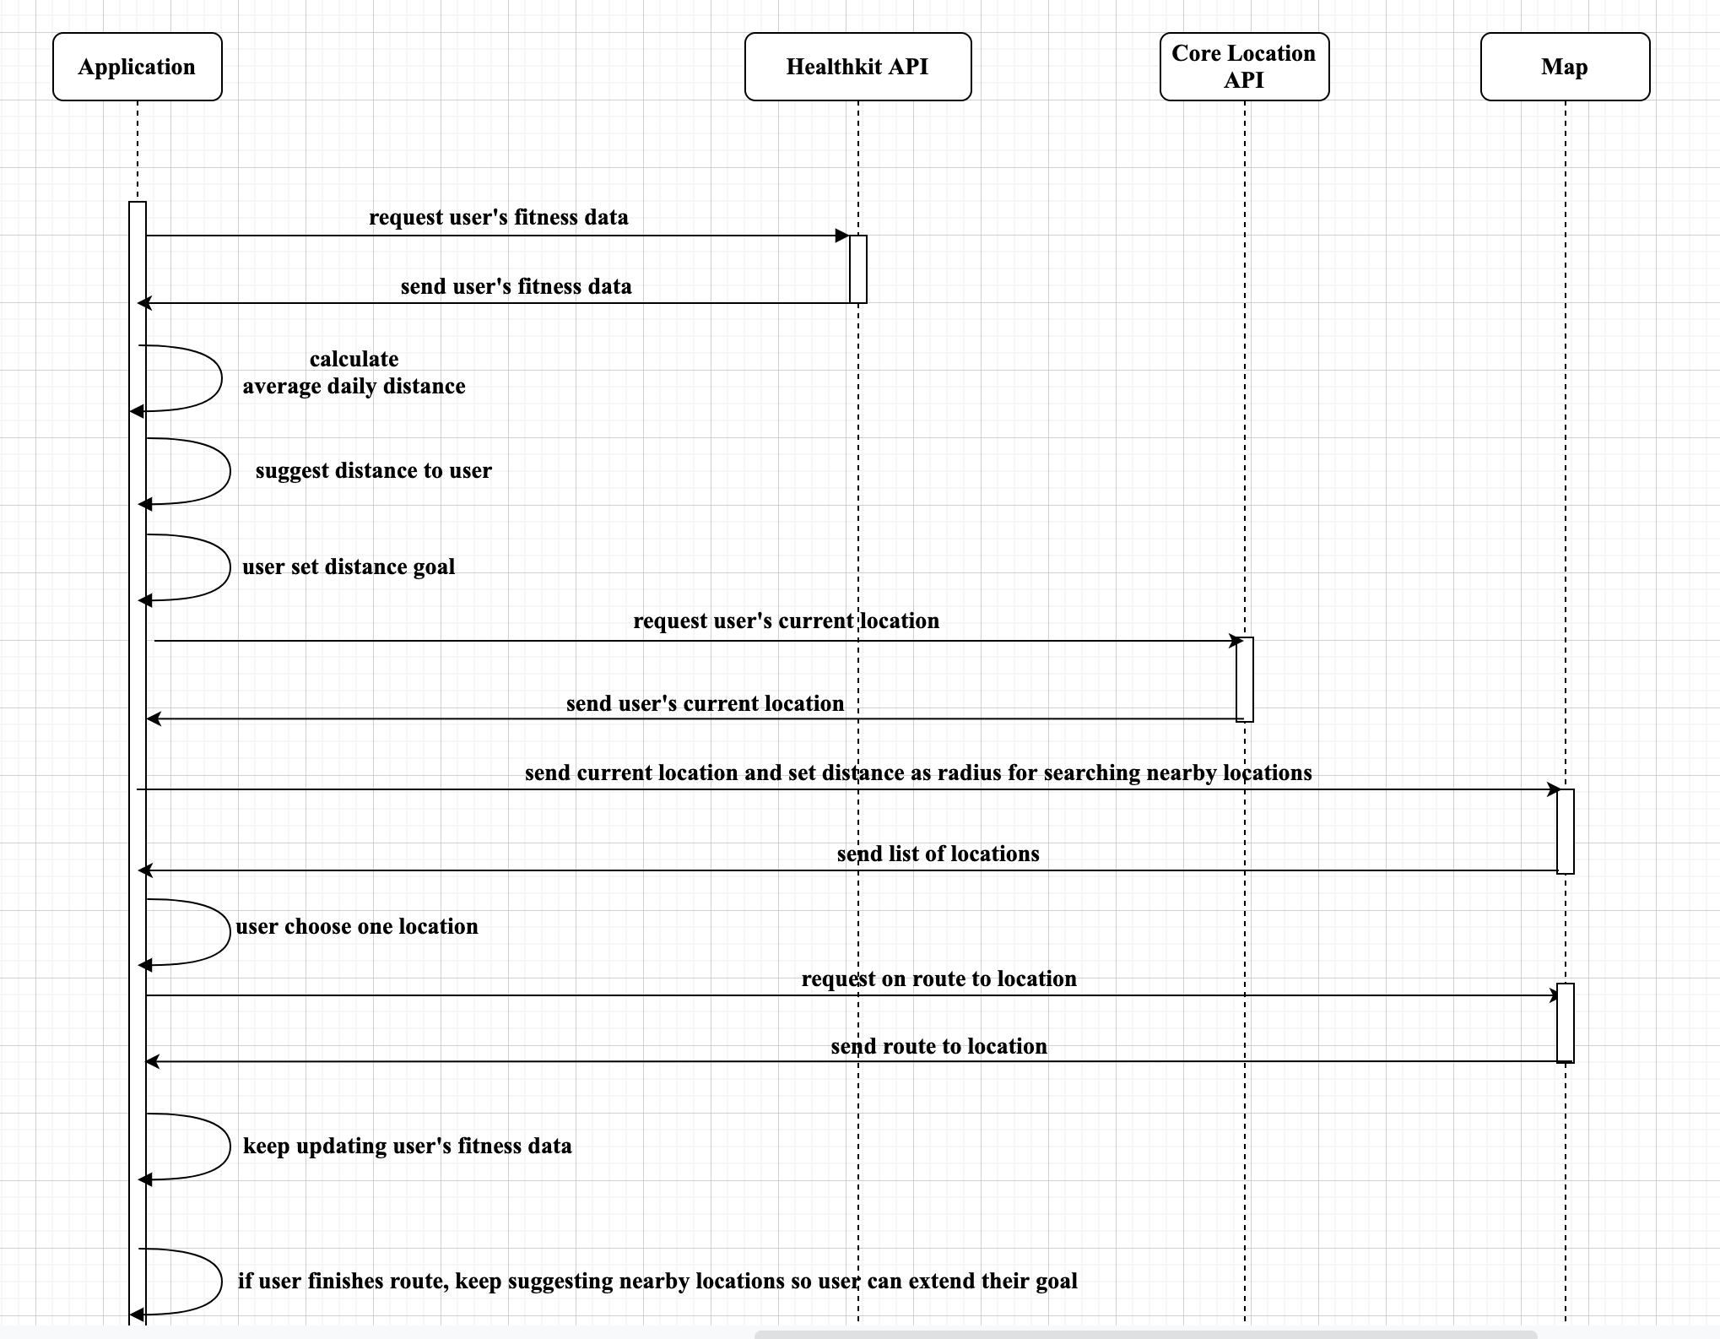

*Figure 1: First UML diagram for the application*

The application will be available every time and everywhere since it will use the current location of users to find nearby locations. The fitness data is always stored and available for the application to use so that the users can always find their activity data. Users are mostly expected to use the application when they want to walk and find a nearby location to achieve their goal of distance. Besides, the application can help users find new routes that they can exercise rather than going on the same routes every time. When the users are on their business trip or travel somewhere new, they can use this to find where to exercise as well.

***Data Sources***

RouteFinder provides relevant information that is personalized for each user and their goals. Using Apple’s HealthKit API, RouteFinder will have access to users personal health data. In real time RouteFinder will give routes personalized to the users remaining distance goal. User’s can also change their goals outside of what their Apple Health suggests to further personalize RouteFinder’s use.

Upon first opening RouteFinder, users must give permission to their phones locational services via Apple’s Core Location API. Once allowed, RouteFinder will take the users current location and compile a list of locations that will allow users to travel to in order to meet their distance goal. Using this list of generated points of interests (businesses/parks/etc) via Core Location, and the remaining distance, we can provide the user with the information they need to decide where they would like to go.

As of now, there is no role of time in our application. Some ideas could be a scheduled time for a walk every day or making the steps taken everyday spaced out instead of trying to complete in one walk. We could also maybe give location recommendations based on the current time of day. For example, during the day, the app could recommend a walk on the beach or at the park.

The application will get biometrics and all health information from Apple Healthkit API and then suggest its distance for the user. The user is required to accept the app suggestion or input their own distance they want to walk. The application will get current location from Core Location API and send the distance as the radius to find nearby location to the Map (Apple Map or Google Map) to get the list of potential locations to exercise. The application then will recommend the routes. The user has the option to increase/decrease distance or accept one of the recommended routes to start walking.

The data we will be collecting will consist of the distance traveled by the user, their physical characteristics like height and weight, and their location history. We will be gathering the distance a user walks everyday by using their health app on their iOS devices which will show the amount of steps taken each day. Through that data, we can also get their height and weight from their health account and estimate the distance based on their stride length. All this data will be located in the Apple Healthkit and Core Location services.

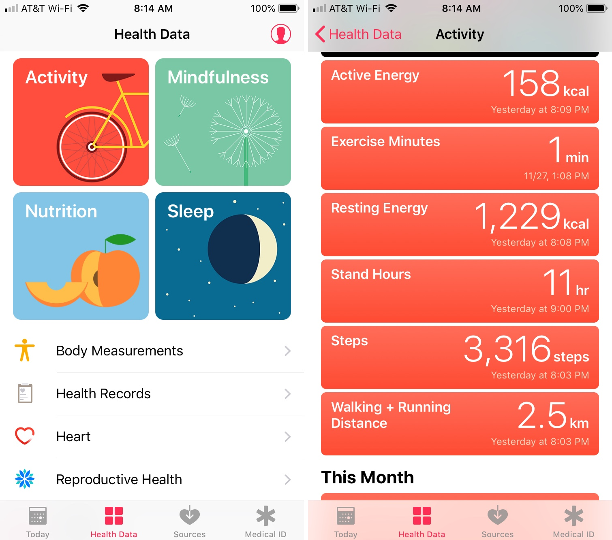

*Figure 2: Apple Health Kit information*

***Data Representation and User Interface***

The application will have multiple screens to display information to the user. When the user first opens the application, they will be asked to specify their intended goal walking distance is for the day (figure 3). Based on the user’s current amount of steps (taken from the Apple Health Kit data) and the intended distance the user would like to walk that day, our application will curate a path to match the user’s goal. This information will be displayed on a different screen (figure 4). This screen will give the user the option to start walking with the designated route, or adjust the distance to find a new walk. There will also be a screen for the user to view past routes and past distances the user walked, which will be displayed on another screen.

We have elected to build our application with multiple pages, to make sure our application is user friendly. Since our target audience targets users of all ages, we must assume that the user is comfortable using an iPhone, but are not tech savvy. The multi page views make it easy for a user of any skill level to find the information they are looking for.

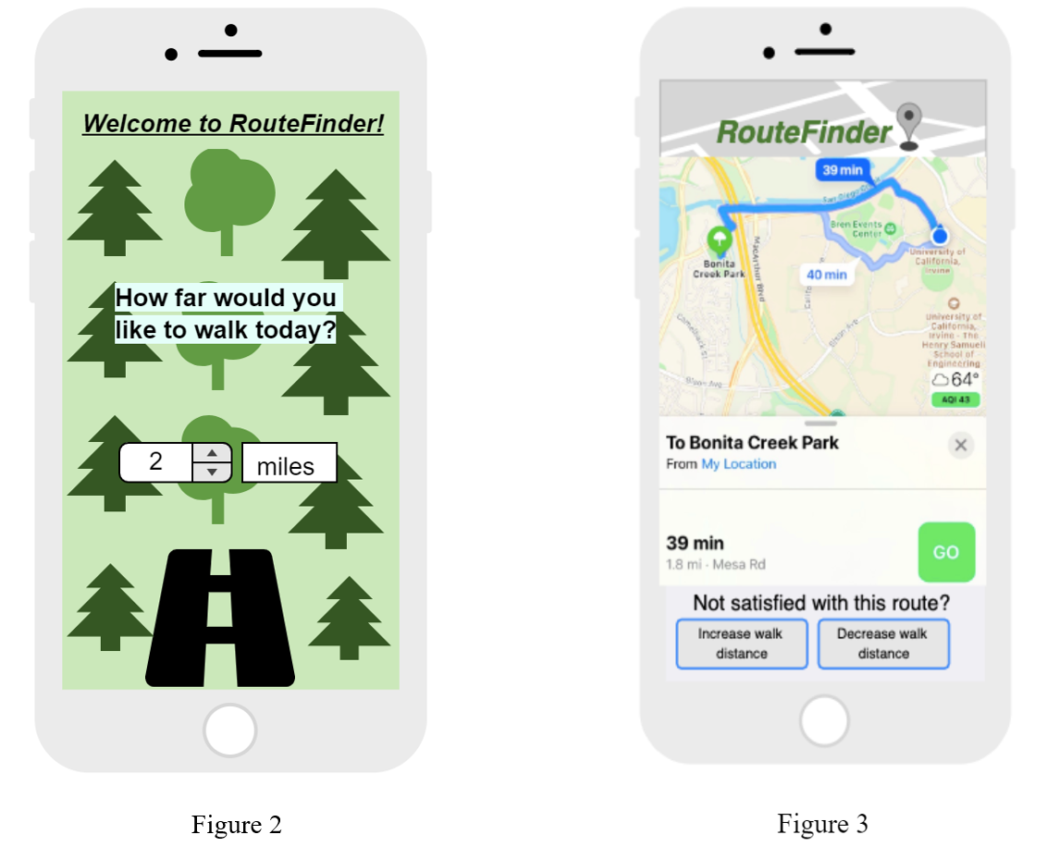

*Figure 3: Main Screen Figure 4: shows user routes*

In order to store data in our application, we will use Core Data. Core Data is a framework provided by Apple which allows us to store, modify, and track data within our iOS application. Core Data uses the SQLite database, a relational database management system that will store data about our user. SQLite will be used in order to store information about the user. Past routes, biometrics, and location data for each user will be stored in the database. Due to our use of Core Data for this application, all user analytics will be stored locally. Using Core Data will allow us to only load the objects we are currently using, which helps manage our memory of our program.

***Challenges***

We are progressing well in developing our application. We have finished designing our application and have created a timeline for the rest of the development process that aligns with the due date of this course.

While we have not run into any major challenges thus far, we anticipate that learning how to use the APIs, Apple Health Kit and Core Location may pose as challenges in developing our application. Since there is not much documentation associated with these two APIs, it may be a learning curve to understand how to effectively use this framework in our application. Apple Health kit consists of many subclasses, so correctly incorporating all necessary classes in our program may pose as a challenge. Additionally, Core Location may be difficult to use due to our lack of prior experience in handling locational data. In order to combat these obstacles in building our application, we intend to rely on Apple documentation to guide us in developing our application.

We don’t anticipate needing specific help from the TAs, but we are aware they are a resource that is available for us.